# Assignment 2

Clone game-of-life project and create gameoflife.war in Jenkins Master. Deploy this on tomcat Slave 1 and Slave 2 using Declarative pipeline.

## Step 1: Launched 3 VMs: 1 JM and 2 Slaves.

## Step 2: Created Job

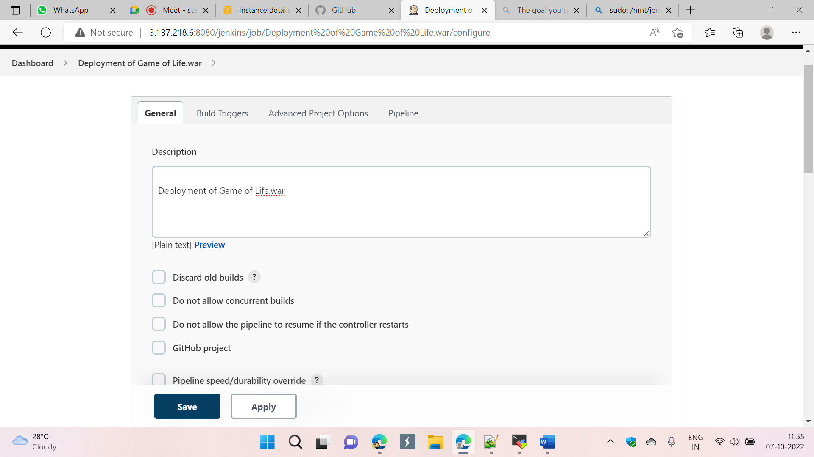

## Step 3: Added pipeline

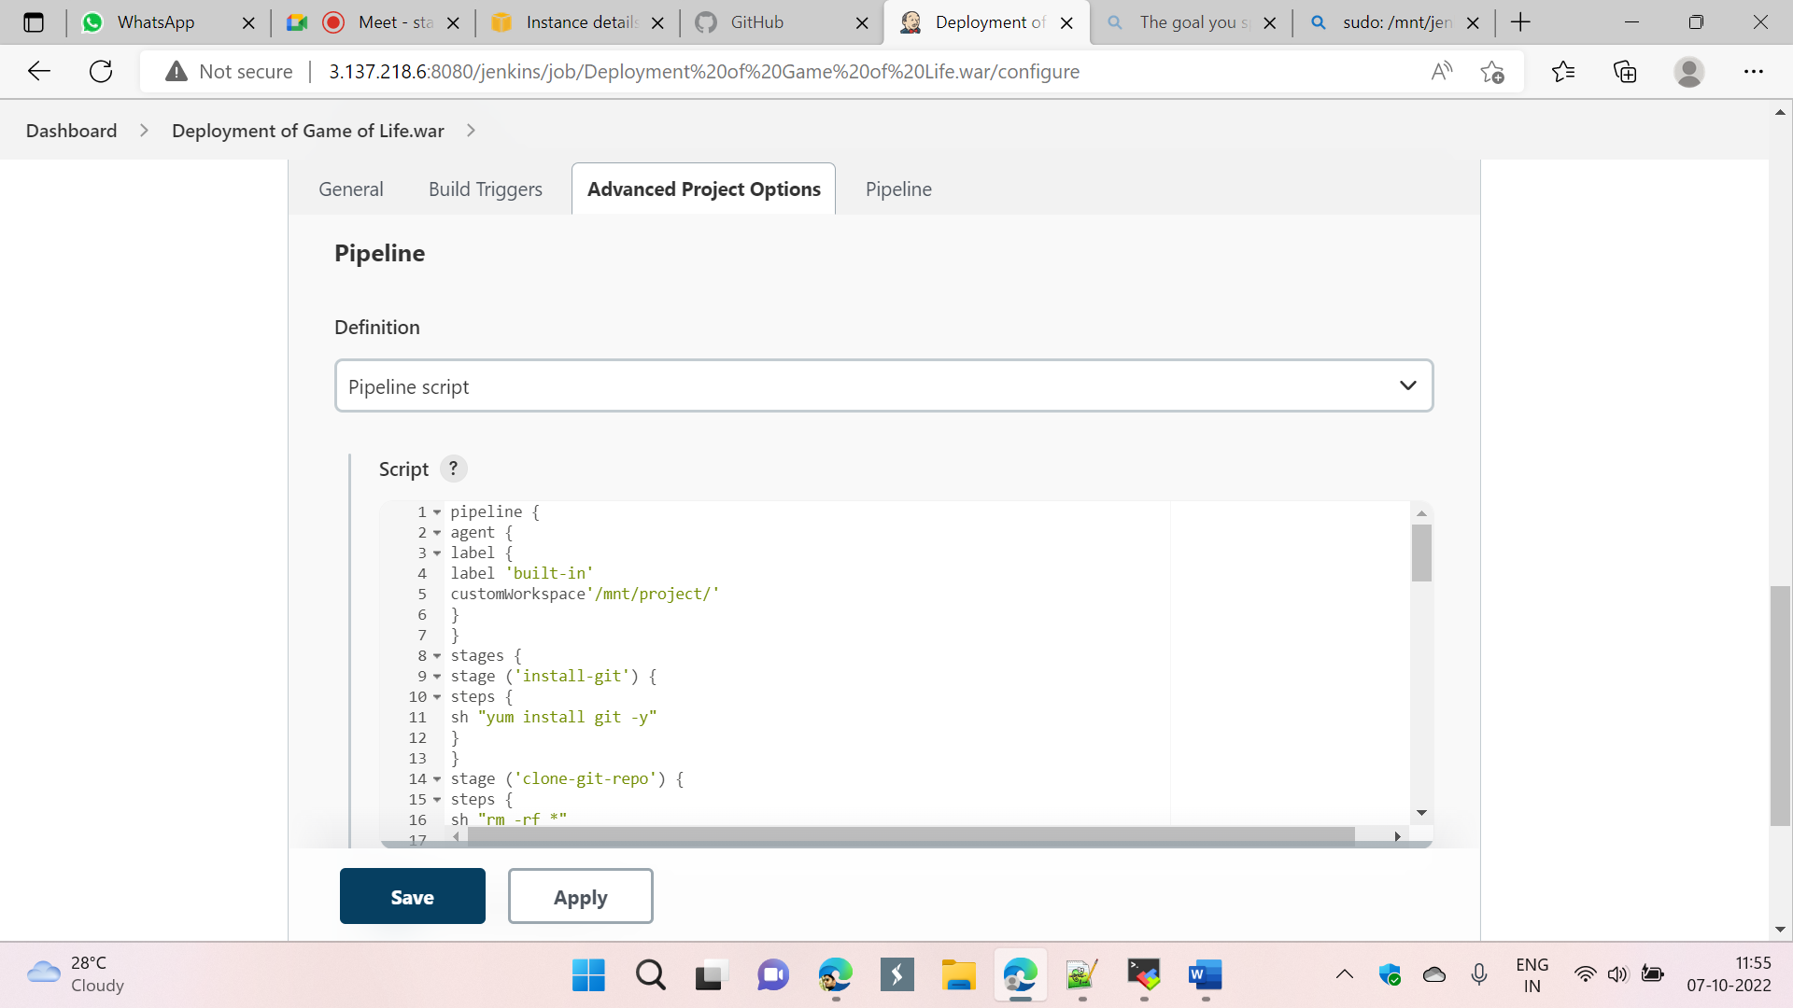

## Pipeline

pipeline {

agent {

label {

label 'built-in'

customWorkspace'/mnt/project/'

}

}

stages {

stage ('install-git') {

steps {

sh "yum install git -y"

}

}

stage ('clone-git-repo') {

steps {

sh "rm -rf *"

sh "git clone https://github.com/aakashchavhan/game-of-life.git"

}

}

stage ('build-app') {

steps {

dir ('/mnt/project/game-of-life/')

{

sh "mvn install"

}

}

}

stage ('copy-app') {

steps {

sh "cp /mnt/ohio-kp.pem /mnt/project/"

sh "scp -i 'ohio-kp.pem' /mnt/project/game-of-life/gameoflife-web/target/gameoflife.war ec2-user@172.31.23.205:/mnt/jenkins-slave1/"

sh "scp -i 'ohio-kp.pem' /mnt/project/game-of-life/gameoflife-web/target/gameoflife.war ec2-user@172.31.36.12:/mnt/jenkins-slave2/"

}

}

stage ('deploy-start-app-1') {

agent {

label {

label 'Slave-1'

customWorkspace '/mnt/jenkins-slave1/'

}

}

steps {

sh "sudo rm -rf apache-tomcat-9.0.67 apache-tomcat-9.0.67.zip"

sh "sudo wget https://dlcdn.apache.org/tomcat/tomcat-9/v9.0.67/bin/apache-tomcat-9.0.67.zip"

sh "sudo unzip apache-tomcat-9.0.67.zip"

sh "sudo rm -rf apache-tomcat-9.0.67.zip"

sh "sudo chmod -R 777 apache-tomcat-9.0.67"

sh "sudo bash /mnt/jenkins-slave1/apache-tomcat-9.0.67/bin/shutdown.sh"

sh "sudo cp -r /mnt/jenkins-slave1/gameoflife.war /mnt/jenkins-slave1/apache-tomcat-9.0.67/webapps"

sh "sudo bash /mnt/jenkins-slave1/apache-tomcat-9.0.67/bin/startup.sh"

}

}

stage ('deploy-start-app-2') {

agent {

label {

label 'Slave-2'

customWorkspace '/mnt/jenkins-slave2/'

}

}

steps {

sh "sudo rm -rf apache-tomcat-9.0.67 apache-tomcat-9.0.67.zip"

sh "sudo wget https://dlcdn.apache.org/tomcat/tomcat-9/v9.0.67/bin/apache-tomcat-9.0.67.zip"

sh "sudo unzip apache-tomcat-9.0.67.zip"

sh "sudo rm -rf apache-tomcat-9.0.67.zip"

sh "sudo chmod -R 777 apache-tomcat-9.0.67"

sh "sudo bash /mnt/jenkins-slave2/apache-tomcat-9.0.67/bin/shutdown.sh"

sh "sudo cp -r /mnt/jenkins-slave2/gameoflife.war /mnt/jenkins-slave2/apache-tomcat-9.0.67/webapps"

sh "sudo bash /mnt/jenkins-slave2/apache-tomcat-9.0.67/bin/startup.sh"

}

}

}

}

## Step 4: Build Now

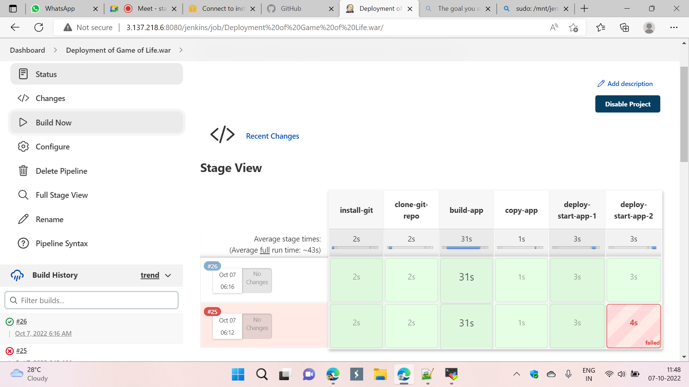

## Step 5: copy paste publicip:8080/gameoflife in browser

